Watermango

There are two options to launch the website:

1. Open it from Visual Studio 2019 and run it
2. Add it to IIS (Internet Information Services Manager)

# How to add a website to IIS

* Go to IIS(Internet Information Services Manager)
* Add a new site

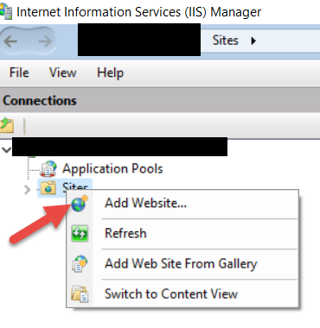

* Fill the site information

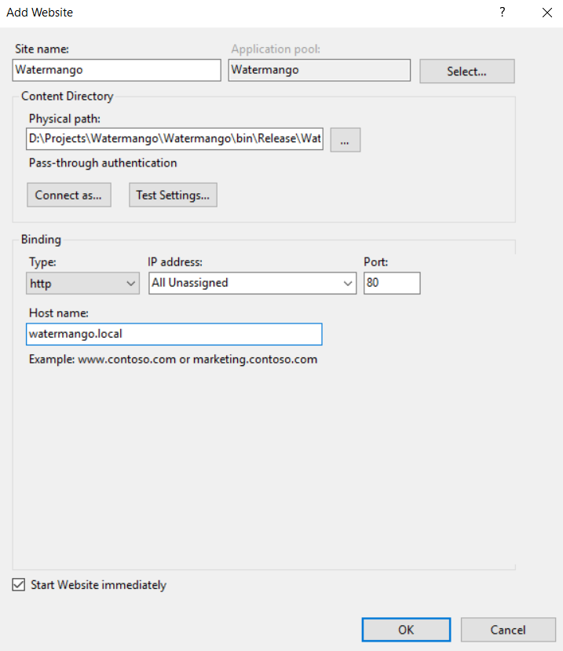

* Add the entry below to the hosts file:

127.0.0.1 watermango.local

* Go to Application Pools

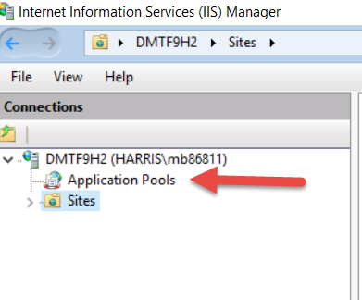

* + Find “Watermango” and right-click on it🡪Click on “Advanced Settings”

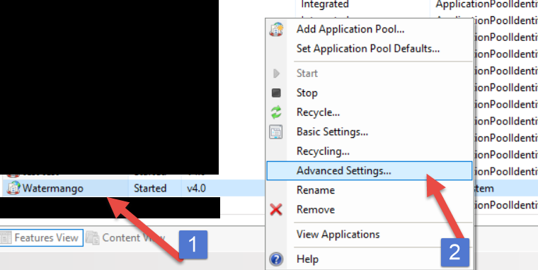

* + Find “Identity” and change it from “ApplicationPoolIdentity” to “LocalSystem”

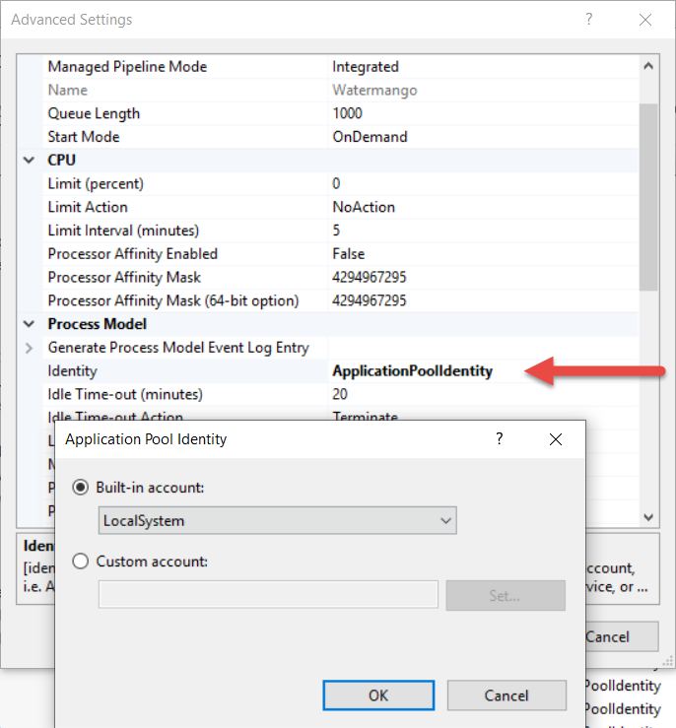

* + Click Ok
* Go back to the website, and click browse

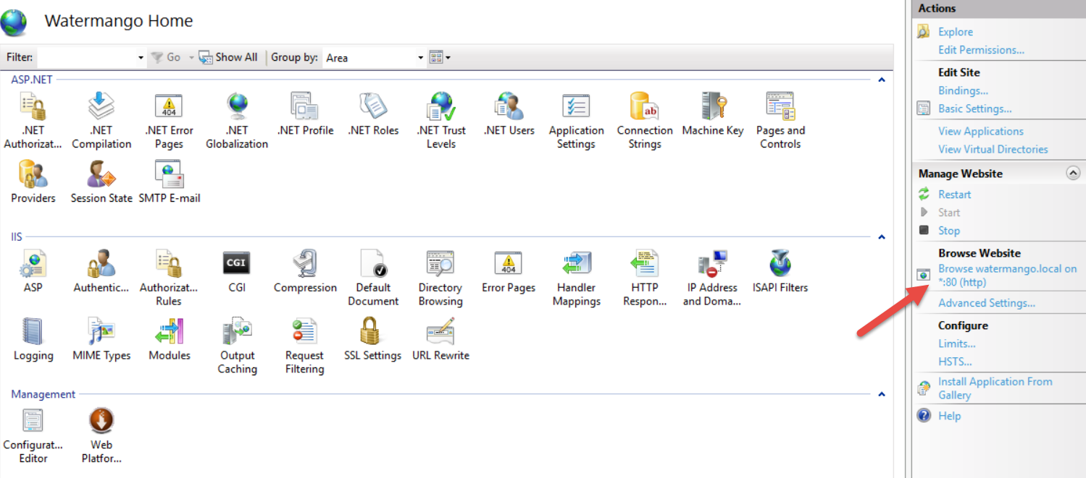

* Enjoy 😊

